1、 Environment

- 1. SD卡配置

- 1.1 下载SD卡映像

- 1.2 向SD卡写入image映像

- 1.3 连接Ubuntu

- 1.4 启动Ubuntu

- 1.5 为Ubuntu LTS设置 Xilinx 开发及演示环境

## 0. Environment

1. KR260 Board

2. Display Port 接口数据线+显示屏

3. 以太网数据线

4. 至少64GB的SD卡

5. USB鼠标+键盘

6. 12V-5A线性电源

## 1. SD卡配置

### 1.1 下载SD卡映像

2、Hardware

2.1、Skill hand -3D- model

Table 14: I/O Bandwidth Requirements for DPU-B1152 and DPU-B4096

|  |  |  |
| --- | --- | --- |
|  |  |  |
|  |  |  |
|  |  |  |
|  |  |  |
|  |  |  |
|  |  |  |
|  |  |  |

Building 3D Models in SolidWorks.

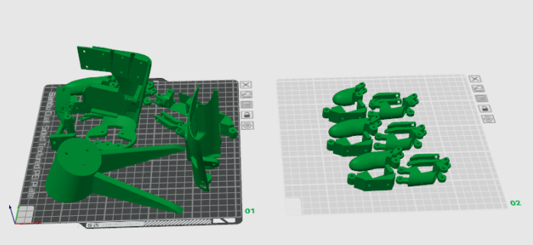

Figure 1: 3D printing structural components

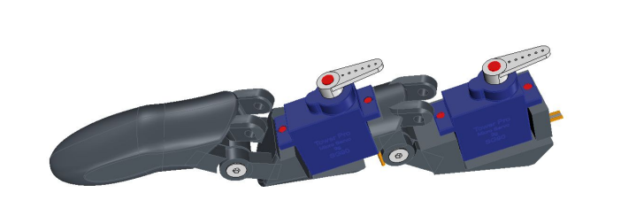

Figure 2: Finger joints and servo motor SG90

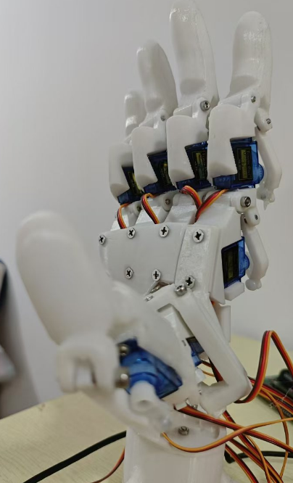

Figure 3: skill hand mechanical structure and servo motor system

1.2、Servo motor control system

The servo motor control system consists of 11 servos motors, and the signal lines of the servos are interconnected with the PCA9685 board,and software driving provided by Arduino.

每个手指由2个舵机控制，舵机的控制过程通过 ardunio 驱动pca9685 完成整个过程，pca9686控制板和舵机的接线如下图，每个手指的上半部分舵机编号为0 ，下半年部分的舵机编号1，以此类推，舵机和pca9685 板上的接口对应关系为 举个例子：

大拇指的编号为0 ， 其中2个舵机的编号为 0_0, 0_1,

食指的编号为编号为1 ， 其中2个舵机的编号为1_0, 1_1,

中指的编号为编号为2 ， 其中2个舵机的编号为2_0, 2_1,

无名指指的编号为编号为3 , 其中2个舵机的编号为3_0, 3_1,

小拇指的编号为编号为4 ， 其中2个舵机的编号为4_0, 4_1,

舵机和pca9685 板上的接口对应关系：

0_0(0)、0_1(1)、1_0(2)、1_1(3)、2_0(4)、2_1(5)、3_0(6)、3_1(7)、4_0(8)、4_1(9)、5_0(10)、 Before this step, it is necessary to install the corresponding library files

Each finger is controlled by two servos, and the control process of the servos is completed by driving the PCA9685 through Arduino. The wiring between the PCA9686 control board and the servos is shown in the following figure. The upper part of the servos for each finger is numbered 0, and the second part is numbered 1, and so on. The corresponding relationship between the servos and the interfaces on the PCA9685 board is as follows:

The number of the thumb is 0, and the numbers of the two servos are 0-0 and 0_1,

The index finger is numbered as 1, with 2 servos numbered as 1_0 and 1_1,

The number of the middle finger is number 2, and the numbers of the two servos are 2 and 2, respectively,

The number of the ring finger is number 3, with two servos numbered 3_0 and 3_1,

The number of the little finger is number 4, with two servos numbered 4_0 and 4_1,

The corresponding relationship between the servo and the interface on the PCA9685 board:

0_0 (0), 0_1 (1), 1_0 (2), 1_1 (3), _20 (4), _21 (5), 3_0 (6), 3_1 (7), 4_0 (8), 4_1 (9), 5_0 (10)

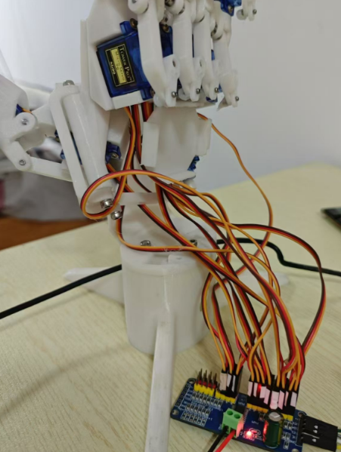

1.2、Serial communication

Kria KR260 FPGA board

* 1. The whole system control

1. Software

2.1、Gesture Recognition process

Using a USB camera to capture video stream data, and Model-based Reasoning application using Kria KR260 FPGA board. By detecting 21 key points on the hand, the features between the edge of the robotic arm and the convex hull are obtained, and the corresponding gesture results are judged based on the features of different gestures,The gesture recognition results support six gestures, namely "1" - "2" - "3" -4 "-" 5 "-" good ". The process of gesture inference and calculation relies on opencv and mediapipe. If you want to end the gesture recognition processing, use the q key on the keyboard to exit. Demo test result:

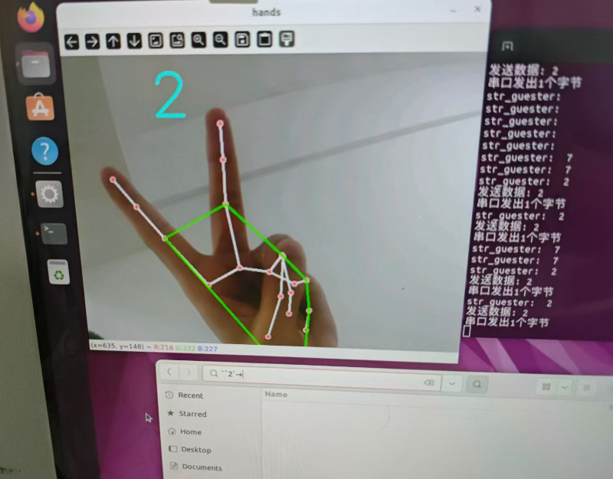

2.1、servo motor control and serial transimtition

Servo motor control process is designed in ardunio IDE, The software control system drives the servo to rotate at different positions based on different gesture results

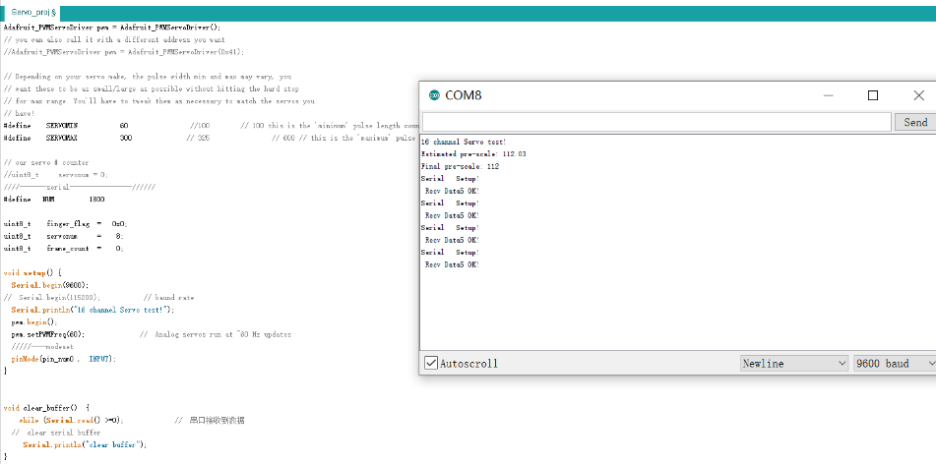

2.1、Ge